24/60G mmWave Radar Wi-Fi Provisioning Documentation
Overview:
The early-stage development for connecting the radar device to the client's platform involves two primary steps:

- Configuring MQTT Connection Information

The device must first be configured with MQTT connection parameters, including the server address, Client ID, username, and password. This is a one-time setup; the configuration data is stored persistently in the module. The procedure is as follows:

Press and hold the button for more than 10 seconds. The module will create a Wi-Fi hotspot named RadarConfig-xxxxxxxxxxxx. Connect to this hotspot using your mobile device. The browser will automatically navigate to 192.168.0.1, displaying the configuration interface. This interface initially shows only the device ID; all other fields must be filled in according to your MQTT server settings.

Fill in the required fields based on your MQTT server configuration. Once completed, click the "Modify" button to submit. Note that the server address must follow this format: tcp://broker.emqx.io:1883.

Upon successful submission, the page will refresh automatically, and the updated data will appear in the information table. Click the "Setup Complete, Exit" button to exit the configuration mode. The module will then reboot.

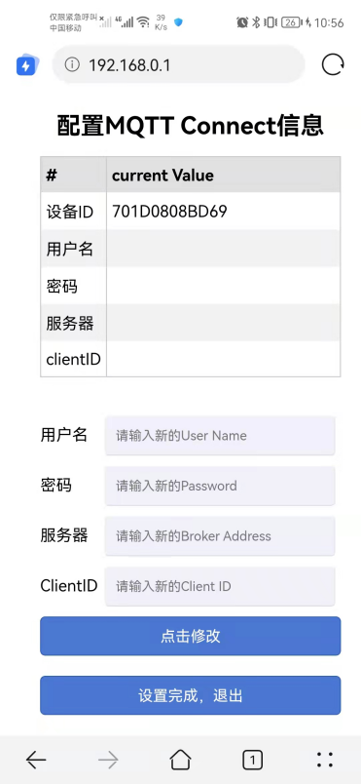  ① | 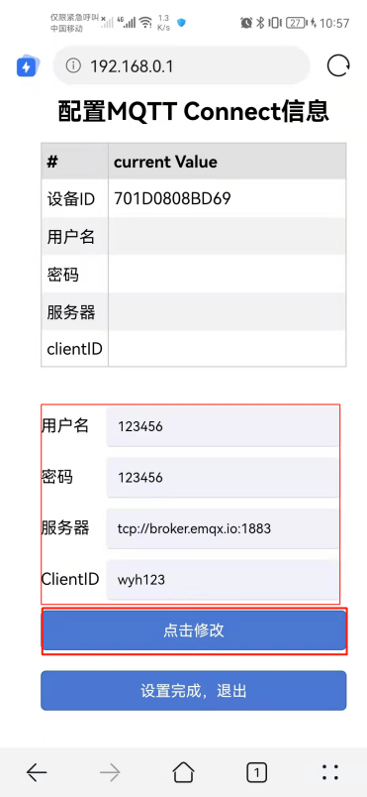  ② | 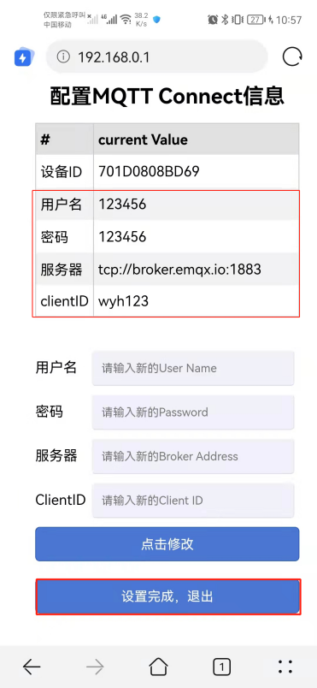  ③

- Wi-Fi Module Network Provisioning

Important: All steps in this section must be carried out while the device's status LED is flashing. If the LED is not flashing, the provisioning attempt will be unsuccessful and must be restarted from the beginning.

Press and hold the button for approximately 5 seconds until the LED turns off, then release it. The LED will begin to flash, indicating the Wi-Fi module has started a Bluetooth service named "Radar_BLE". Ensure Bluetooth is enabled on your mobile device, then use the Android application RadarConfig to initiate provisioning. Please note that this application currently only supports Android devices. The source code can be found at: https://github.com/249263431/Android_BK_BLE_WIFI_NEW_2024031901. The provisioning process has a maximum duration of 90 seconds. If provisioning is not completed or fails within this time, you must press and hold the button again to restart the procedure.

Launch the RadarConfig Android app (with the device LED flashing). Select the "Radar_BLE" Bluetooth device from the list, choose the desired Wi-Fi network (SSID), and enter its password.
Note: If the Bluetooth device list initially appears empty, please wait a few moments for the scan to complete; the "Radar_BLE" device should then be displayed.

Tap the "Provision" (or "Configure") button to start the network configuration.

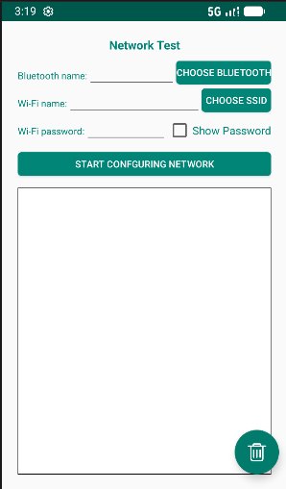

- Configuring the Module via Serial Port Commands

The module can also be configured via serial port commands. Note that the serial port used for configuration is the same as the one used for radar communication. Therefore, during configuration, do not connect the radar until the configuration is complete.

Configuration commands are sent using a serial terminal tool. The baud rate is 9600 (note: the 60G radar baud rate is 115200). Important: Each command must end with a carriage return and line feed (\r\n), which signals the end of input. After configuration is complete, power cycle the module.

1. setup - Enable/Disable Configuration Mode

The setup command is used to turn configuration mode on or off. Enter setup on followed by a carriage return and line feed to enable configuration mode. The following setting commands will only take effect after this command is executed.

Example:

setup on

Response:

[setup] success

2. mqttUser - Set, Get, or Erase MQTT Username and Password

This command is used to set the MQTT username and password. Both fields support a maximum length of 32 bytes.

To set the username and password, use mqttUser set followed by the mqttName and mqttPwd parameters.

To get or erase the current settings, use mqttUser get or mqttUser erase without any additional parameters.

Example:

mqttUser set albert 123456

Response:

[mqttUser] success albert 123456

3. mqttBroker - Set, Get, or Erase MQTT Broker Client ID and URL

This command is used to set the MQTT broker's Client ID and URL path. The Client ID supports a maximum length of 32 bytes, and the URL supports a maximum length of 64 bytes.

To set the Client ID and URL, use mqttBroker set followed by the clientId and url parameters.

To get or erase the current settings, use mqttBroker get or mqttBroker erase without any additional parameters.

Example:

mqttBroker set beken-mqtt tcp://broker.emqx.io:1883

Response:

[mqttBroker] set success beken-mqtt tcp://broker.emqx.io:1883

4. wifiConfig - Set, Get, or Erase Wi-Fi SSID and Password

This command is used to configure the Wi-Fi SSID and password. The SSID supports a maximum length of 32 bytes, and the password supports a maximum length of 64 bytes.

To set the SSID and password, use wifiConfig set followed by the ssid and password parameters.

To get or erase the current settings, use wifiConfig get or wifiConfig erase without any additional parameters.

Example:

wifiConfig set Micradar SZ99iotA

Response:

[wifiConfig] set success Micradar SZ99iotA

5. webConfig - Enable/Disable Web Configuration Interface

This command is used to enable the web-based configuration feature. After setting webConfig enable, the module will create a hotspot named RadarConfig-XXXXXXXXXXXX upon reboot. Connect to this hotspot with your mobile device, open a browser, and enter 192.168.0.1 to access the configuration interface. Modify the settings as needed, click "Modify" to submit, and then click "Setup Complete, Exit" to finalize the configuration. The module will then restart automatically.

Example:

webConfig enable

Response:

[webConfig] success

